7. Remote Triggering of a Parameterized Build
Step 1: Configure a parameterized build in Jenkins
  - Open the browser and go to Jenkins dashboard by typing localhost:8080 in your browser. Provide the credentials and click on Sign in.

  - Click on Manage Jenkins. From the list of options, choose Manage Plugins.

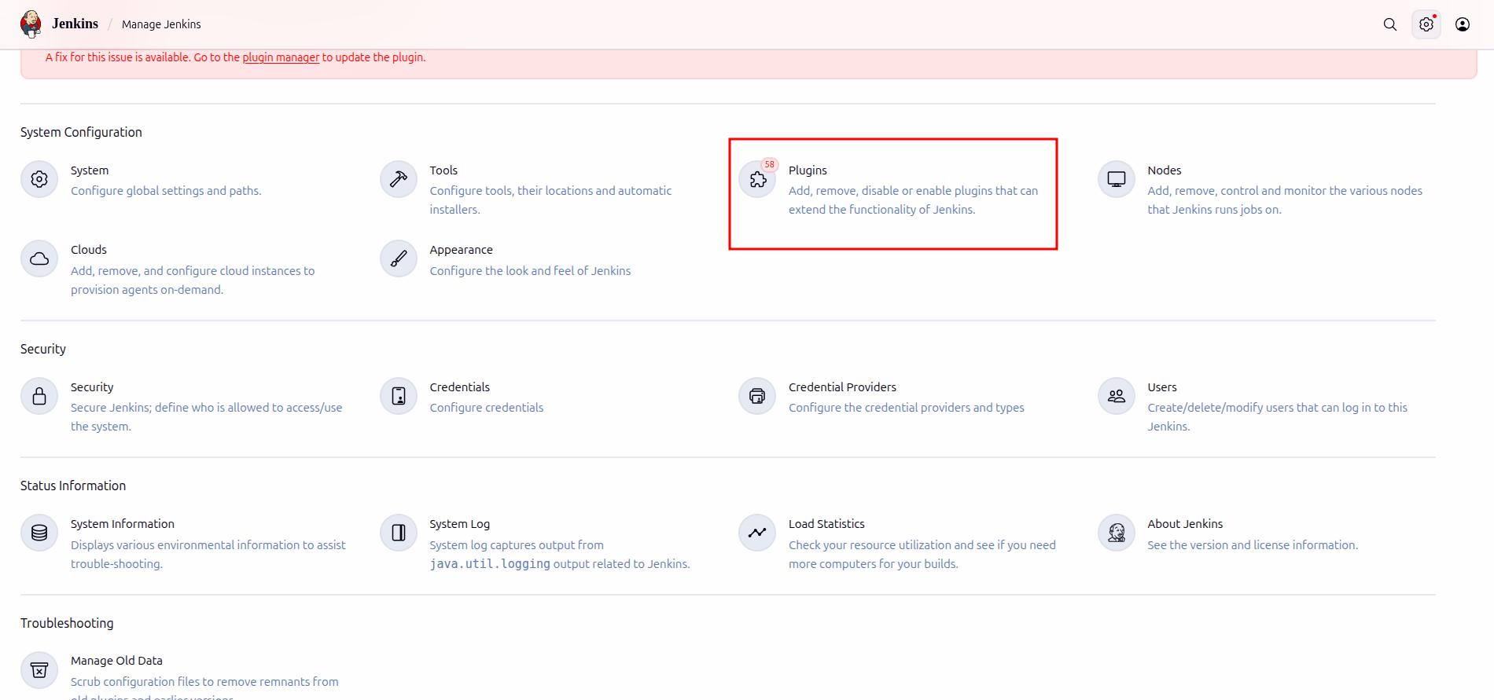

  - Under the Available tab, search for Build with Parameters Plugin.

Select the checkbox in front of the plugin and click on the Install button.
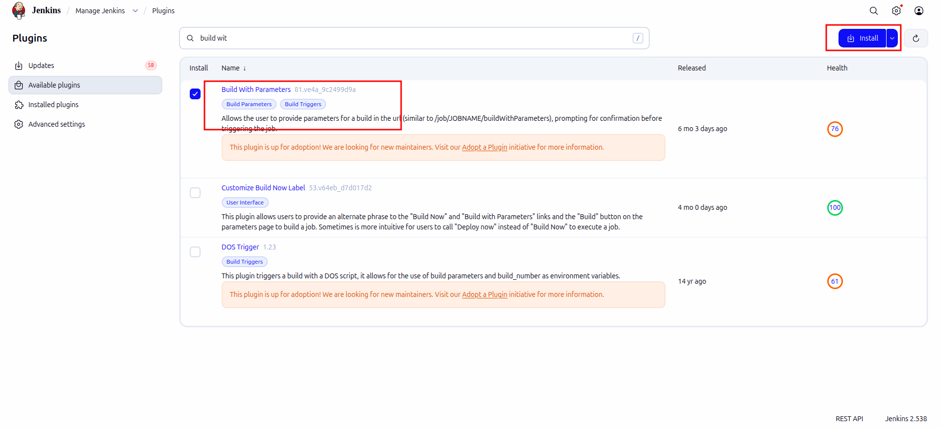

  - Go to the Jenkins Dashboard, click on New Item in the Jenkins dashboard.
Enter a name for your project.
Select the Freestyle project as the build job type.
Click on OK.
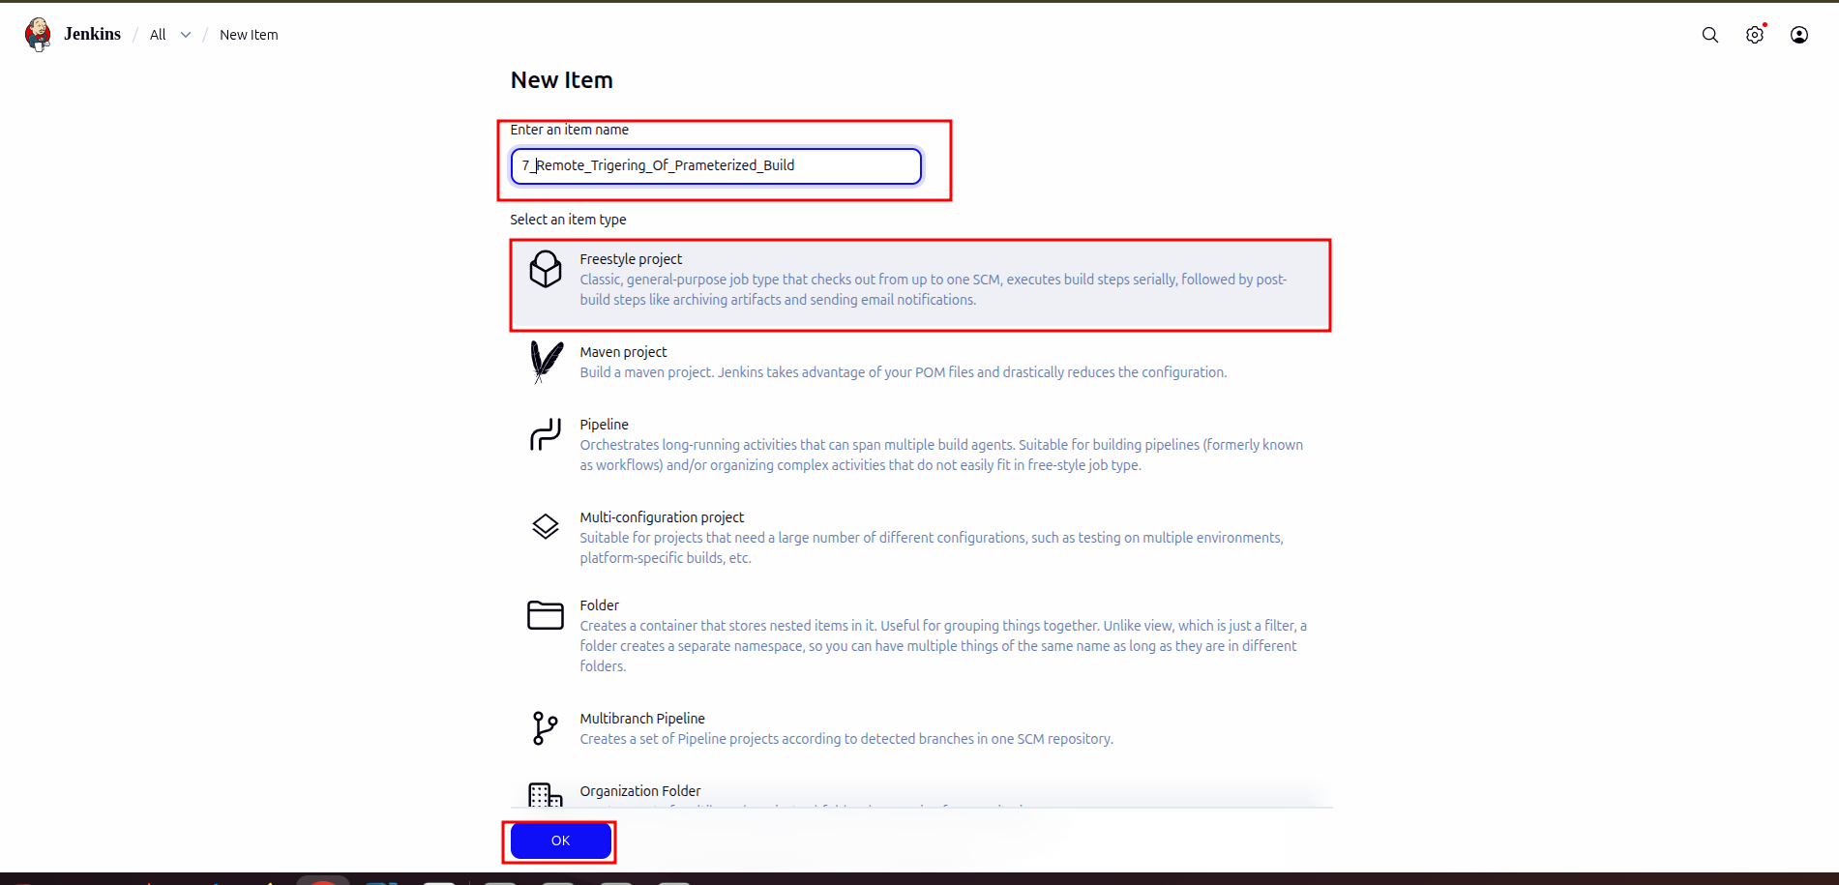
  - On the configuration page, select the checkbox next to text that states, This project is parameterized.
Click on the Add parameter button that appears.
From the drop-down menu that appears, select String Parameter.
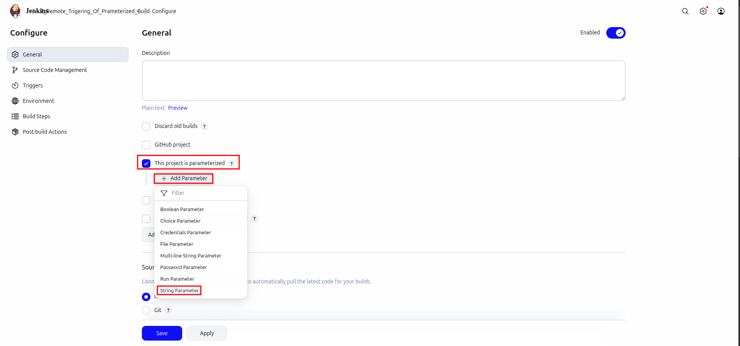

  - Enter the Name of the parameter as my_param, and enter the Default Value. (Ex: Hello).
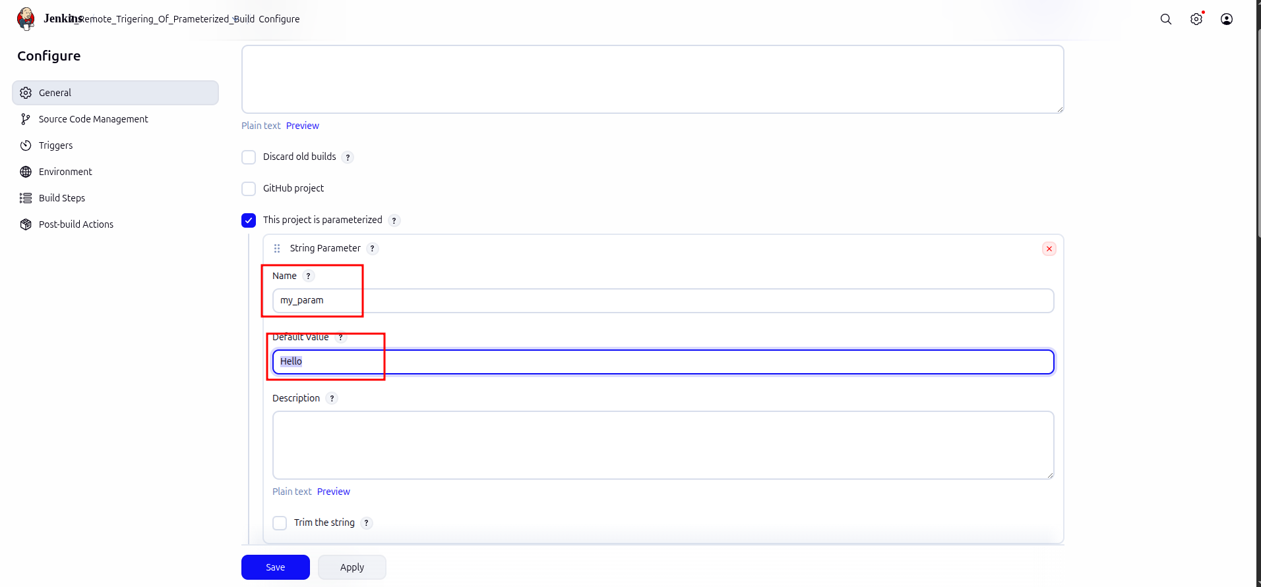

  - Under the Triggers section select Trigger builds remotely and type <Authentication Token> (ex. Madhuri) as the token value.

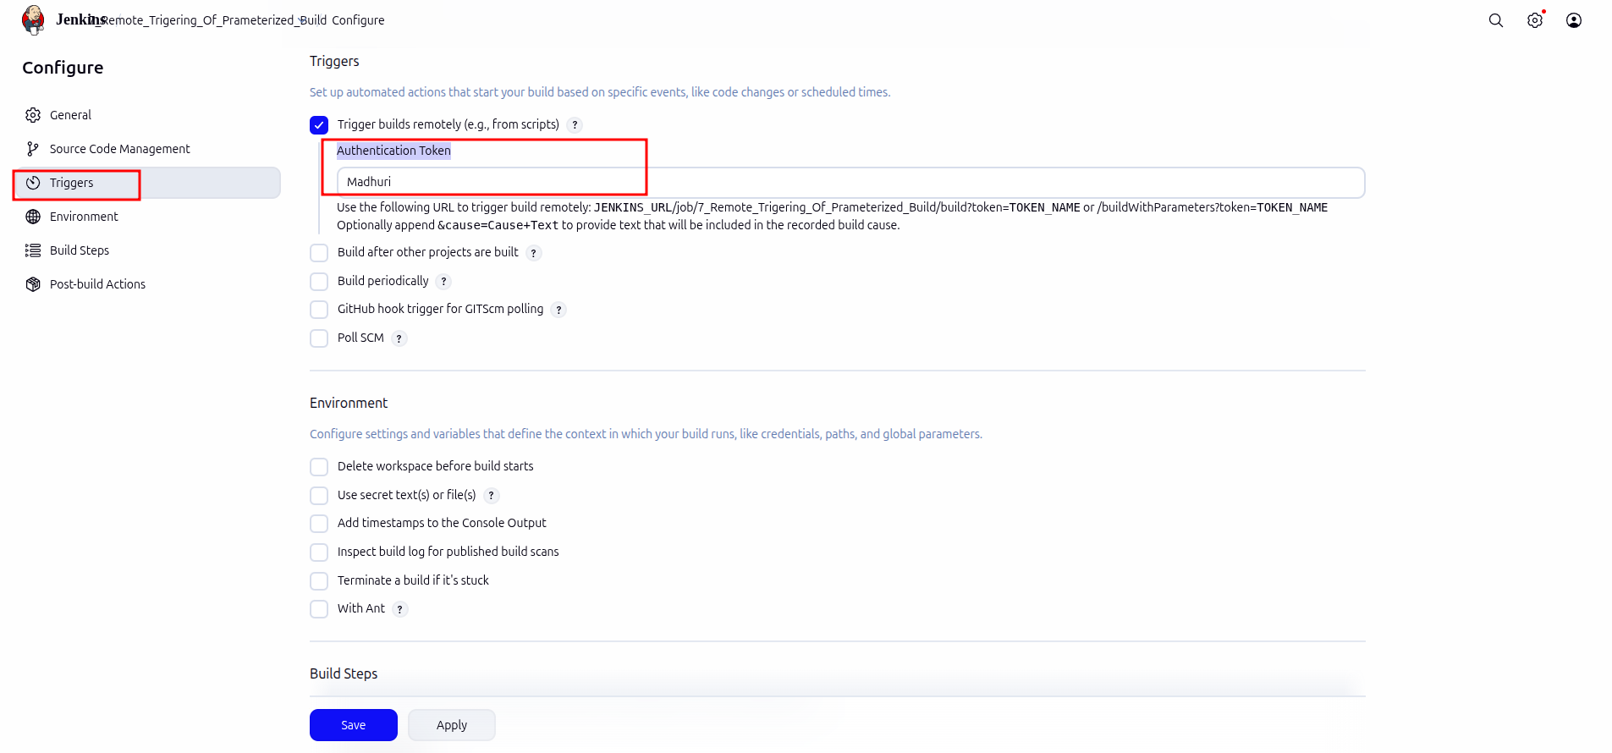

  - Scroll down to the Build section and click on Add build step.

Select Execute Shell Command from the drop down that appears.
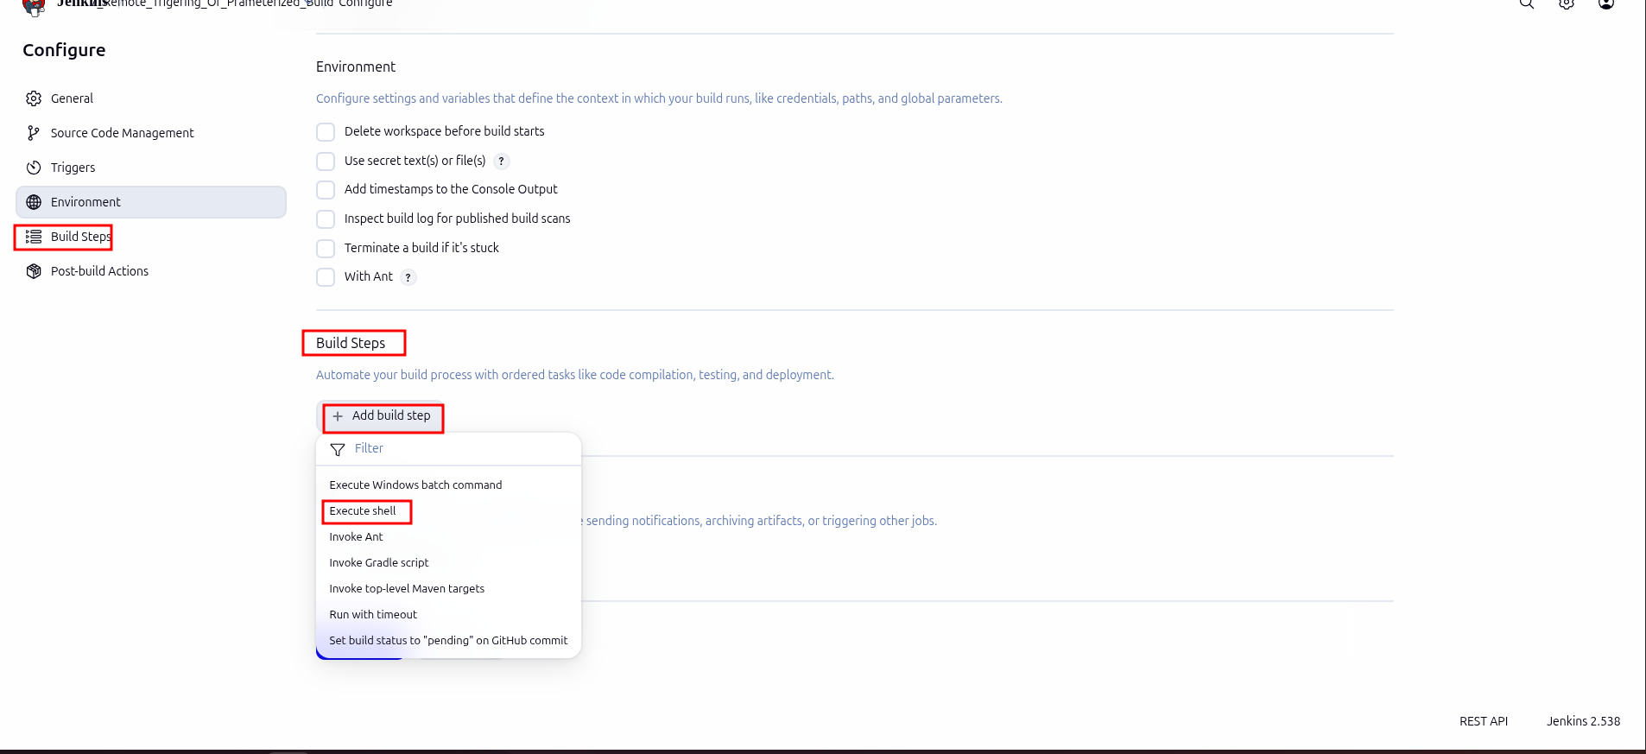

  - In the text input area that appears, enter the following text: echo $my_param
Click Save.

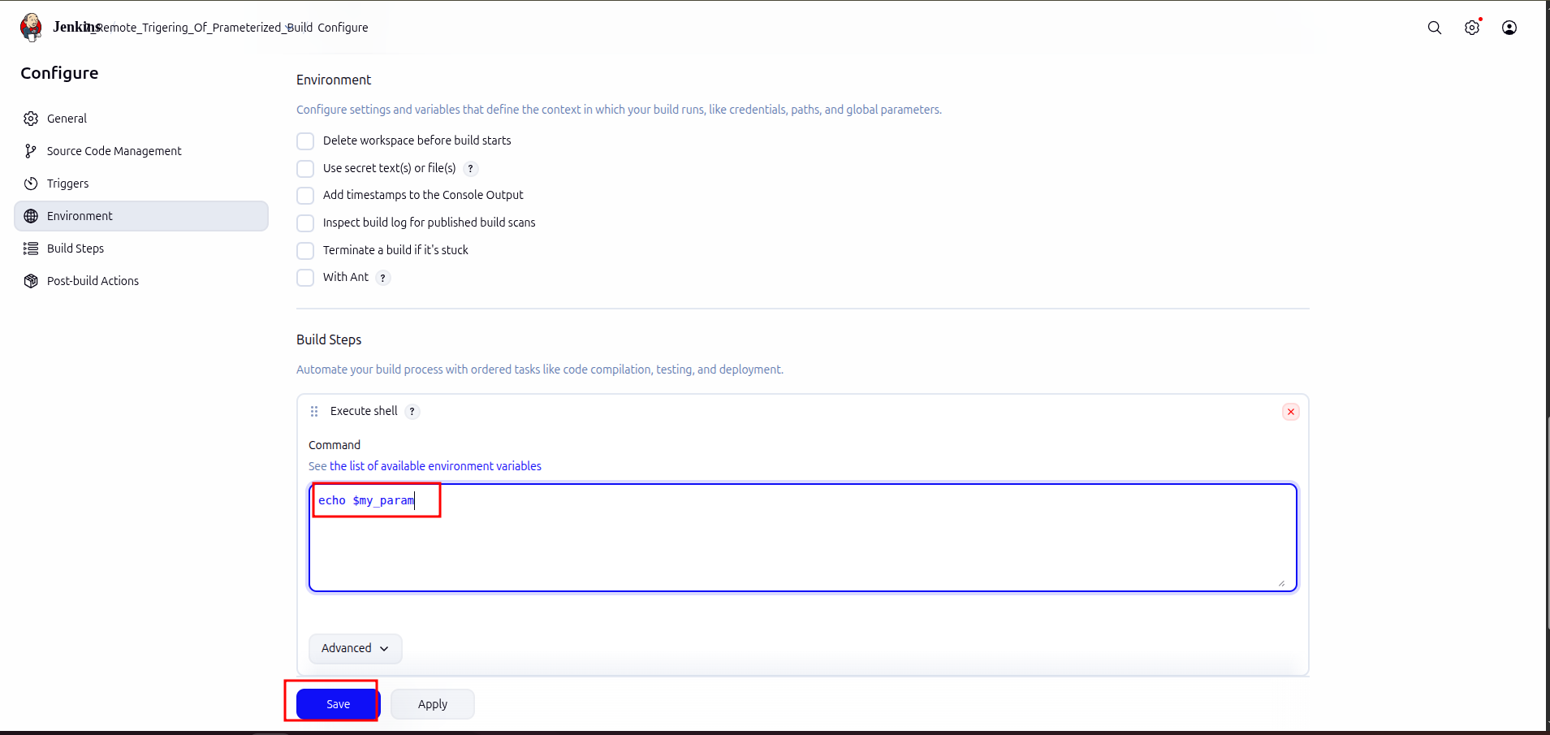

Step 2: Triggering a parameterized build remotely

2.1 Copy the URL to the job from the project window.
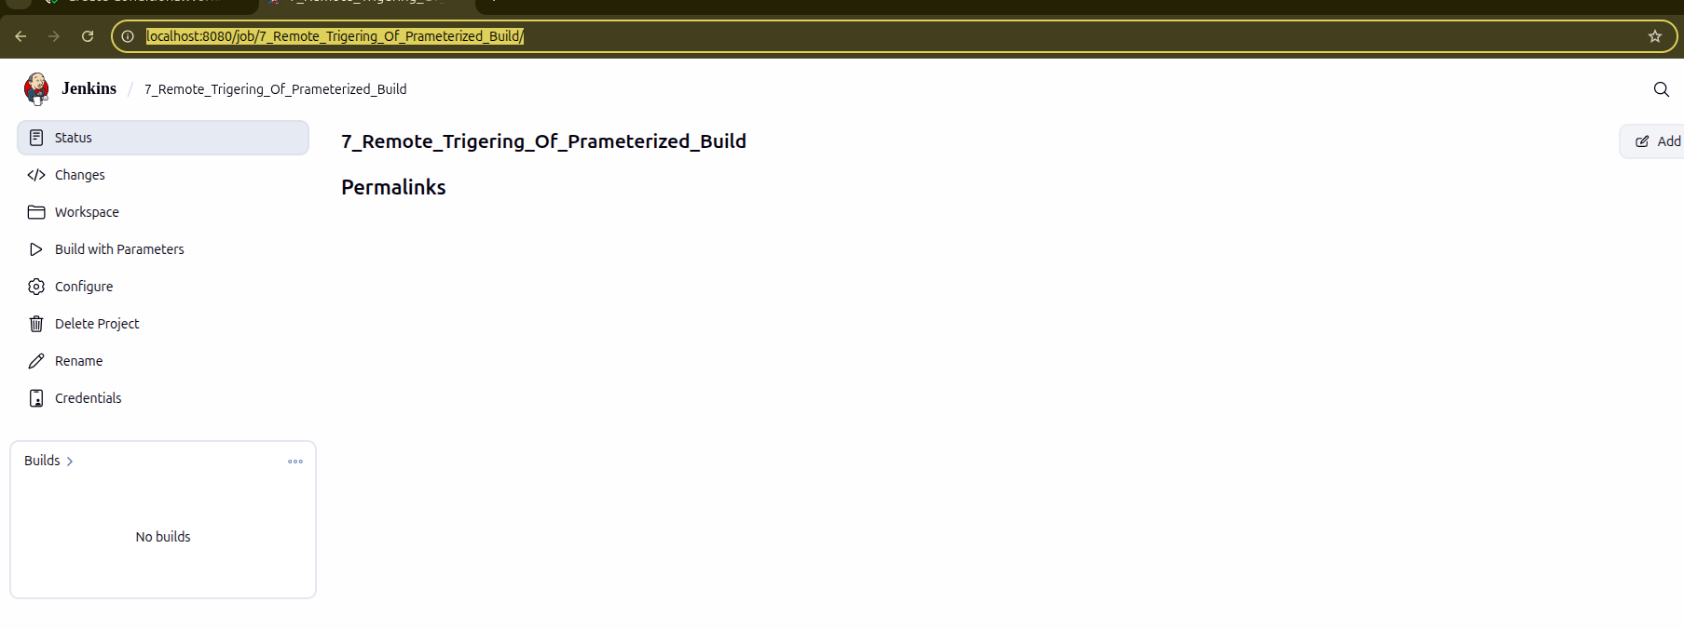

2.2 Open the terminal.
2.3 Suffix the parameter and its value to the URL copied in the previous step and send a GET request using Curl.
curl -X GET <YourJenkinsJobUrl>/buildWithParameters?token=Madhuri

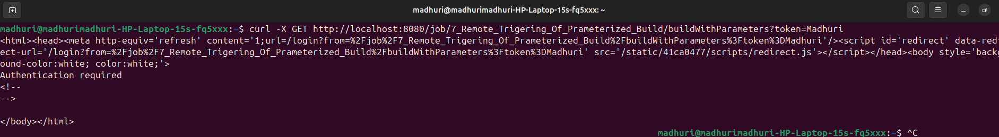

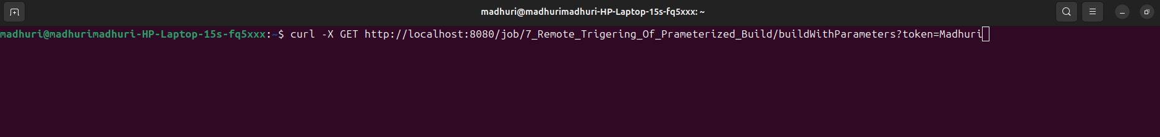

Note: In case you get an authentication error, check your security settings in Manage jenkins > Configure Global Security . It should be configured as shown below:

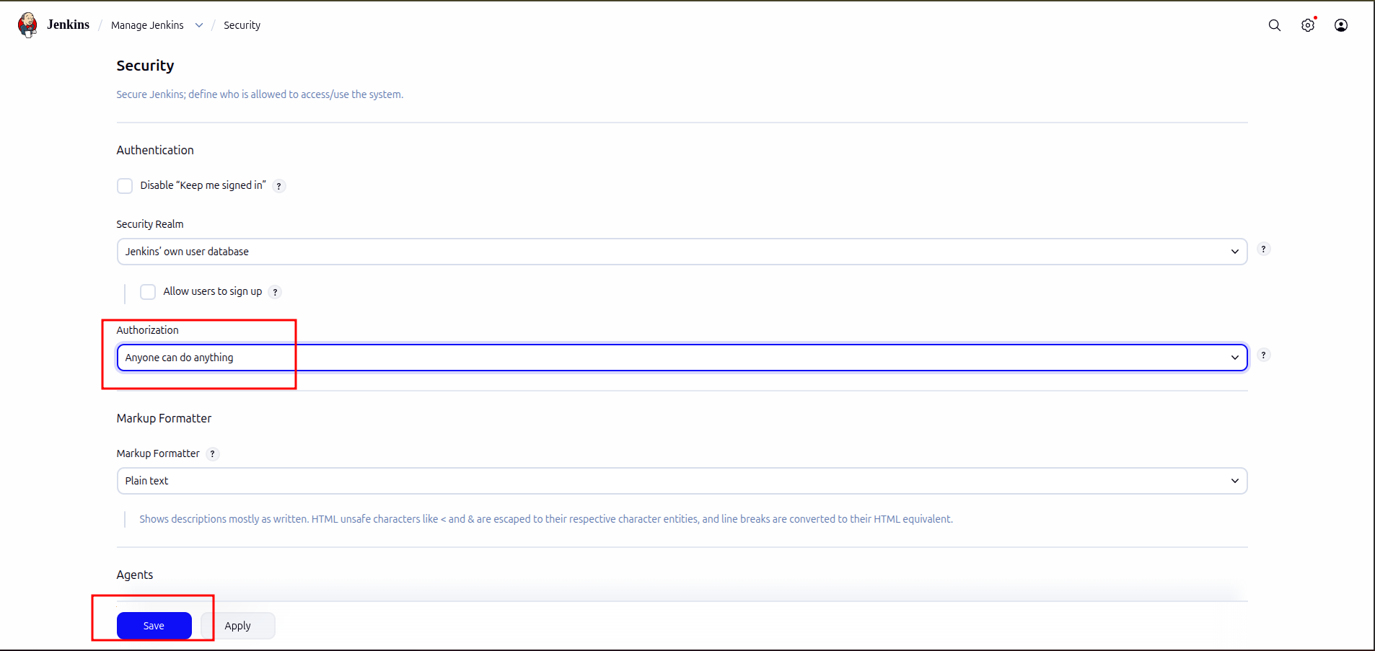

  - Open the job in the Jenkins UI.
  - Click on the Build History to view the build results.
  - Click on the Console Output to view the build logs.
  - The parameter value will be displayed in the console output.

